
PLANVIEWER INSTRUCTIONS

Insert the CD into your computer and the PlanViewer main menu will automatically pop up.
If this does not happen, go to your desktop, double click on My Computer, and select Planviewer (D:).

Main Menu
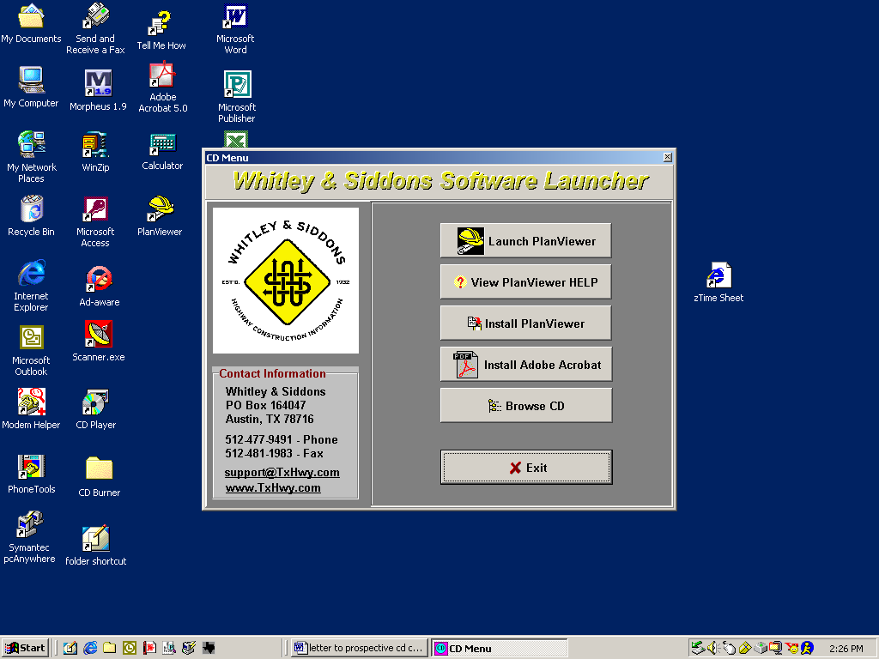

To View Plans Using PlanViewer:

Select “Launch PlanViewer” to open the program.

Click the “Lookup” button on the left side of the screen to bring up the plans.
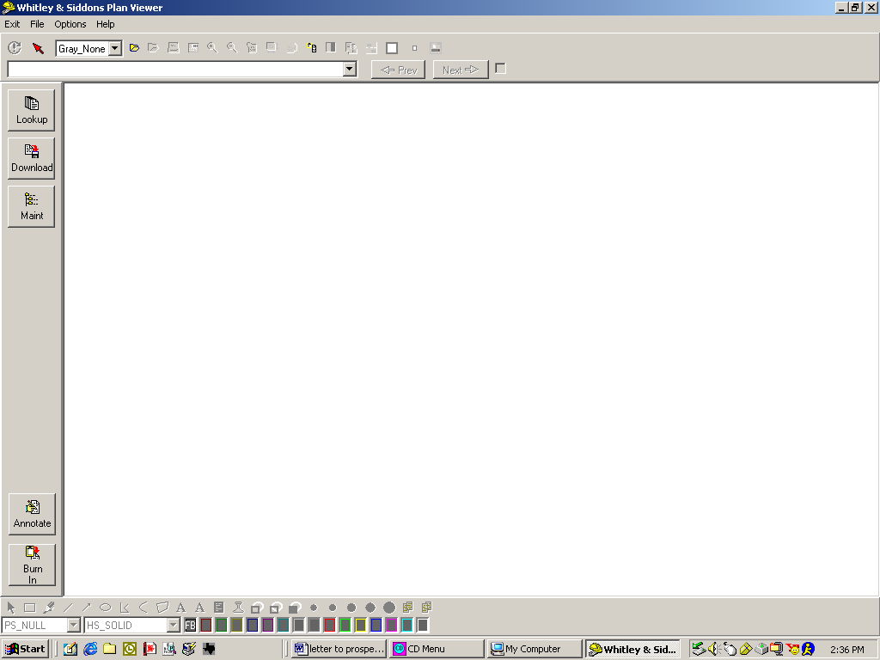

Select the Letting (1) you want and then the Plans (2) you want.

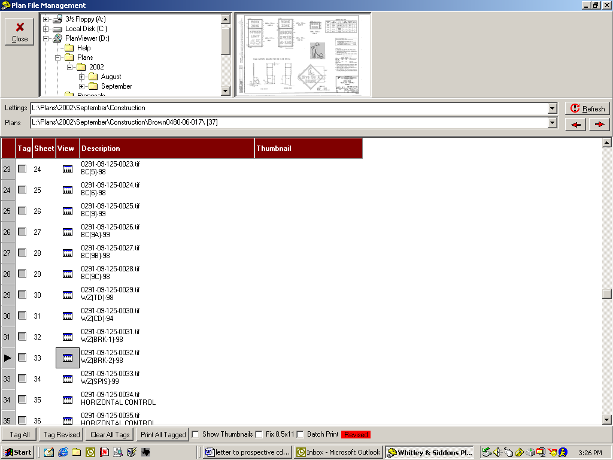
1

2
Click once for thumbnail
Double-Click for full size.
Print
Thumbnail

You can scroll through the pages using the thumbnails (appear at top) or double-click on the individual page. You can also choose to print select sheets by clicking the Tag box for each sheet you would like to print, the select Print All Tagged. If you want all the sheets for the set, click the Tag All button and then select Print All Tagged.

Once you double-click on the page, a full size picture will appear. You can use the Arrows at the top to flip through pages. If you would like to Print that page, check the box beside the “Next” Arrow to tag it for printing. Once you have tagged all that you want, you must return to the index sheet page to print the tagged pages. If you would like to go back to the index sheet window, click back on the “Lookup” button.
1
2
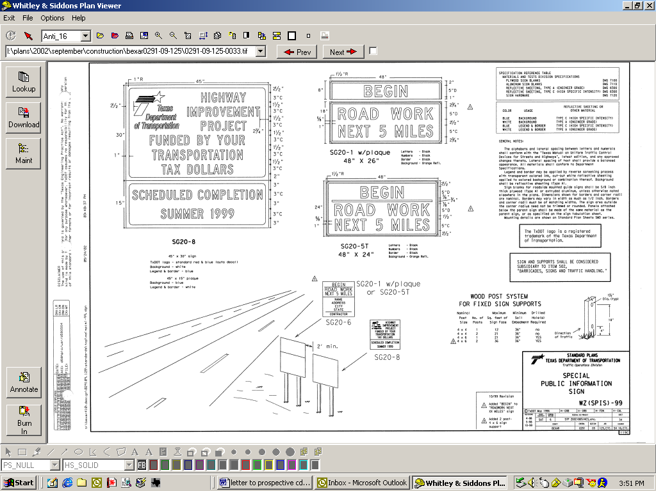
Flip Pages
Return to Main Screen
Print

You can also ZOOM on the individual full size pages by clicking on the white box button 1 (see above) and then dragging it over the area you would like to see enlarged. To restore it back to the normal view, click the restore button 2 (see above) on the same tool bar.

To see all the Lettings on the CD, single click on the plus signs beside Planviewer (D:), Plans, 2002. The months that are on the CD will appear under 2002. To view all months (in the example below…August and September) double click on 2002. Now you will be able to find all the Lettings on the CD and the plans listed for that month. You can also use this process if you decide save older plans to you C Drive (C:).
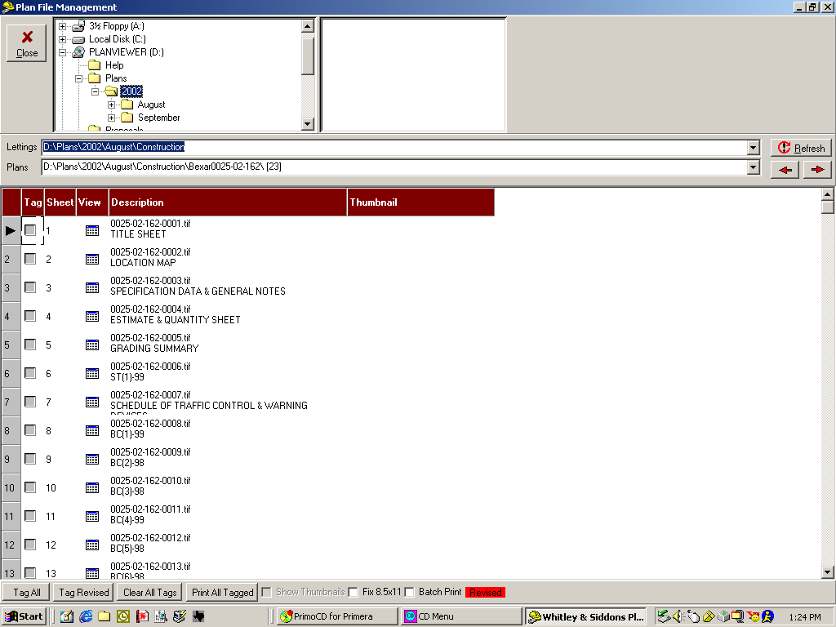

Find all the Lettings Here
Single Click
Double Click

To View Proposals:
In order to view proposals you must have Adobe Acrobat installed.

If you do not have it installed, click on Install Adobe Acrobat (1) and follow the directions it provides you.

If you do have Adobe Acrobat installed, click the Browse CD button (2).

1

2

Double click on Proposals and select the project proposal you would like to view.
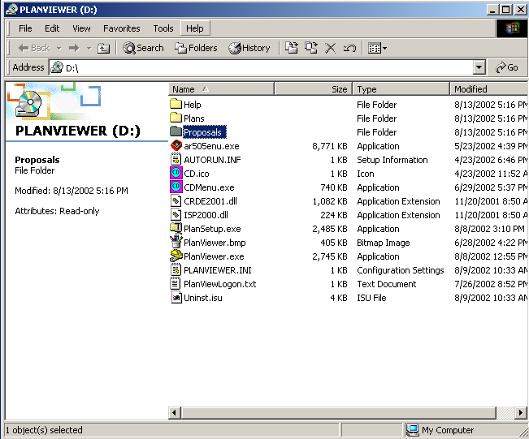

To Download Plans:
Open Planviewer like normal by clicking on Launch PlanViewer.

When you get to the START PAGE, click on Download.

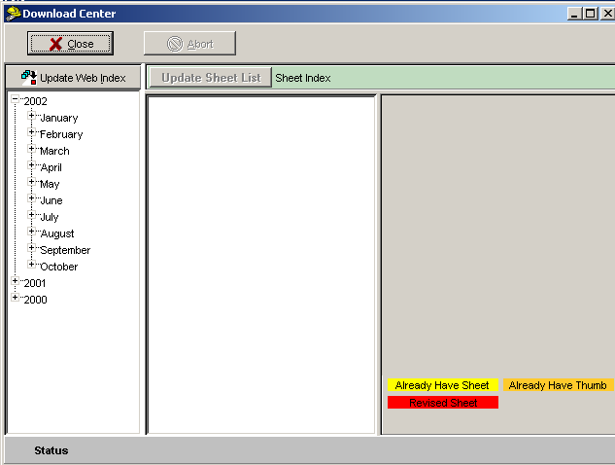
The Download Center Screen will appear.

Click on Update Web Index. This allows your computer to look at the files available to download through Whitley & Siddons.

The next two screens that will appear are A and B.

A

B
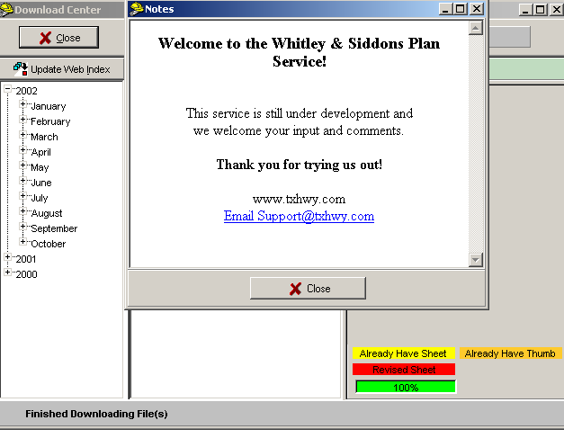
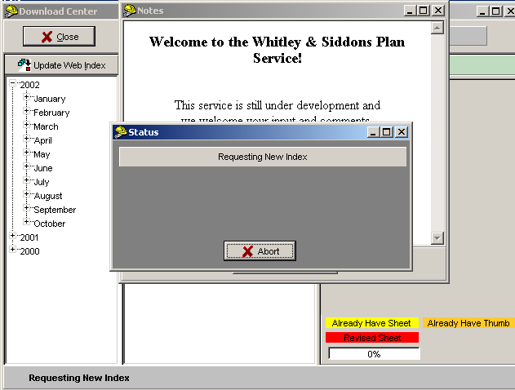
When the Status box on Screen A has disappeared, the Notes box on Screen B will appear. If you have a suggestion or question, please click on the email address and write us; otherwise, just click Close. All of the plans are now available for you to download.

Choose the month you would like to view by clicking on the month’s name (1). Then click on the type of project you would like to look at (i.e. maintenance or construction). A list of all of the projects along with their CSJ numbers will appear. This can take a few minutes depending on your internet connection.

Whitley & Siddons updates the files as soon as they are received from TxDOT; therefore, new projects or new pages (like revision sheets) can be added periodically. Each time you enter the Download Center, you need to click the Update Web Index and the Update Sheet List (2). This will pick up any sheets or jobs you may be missing.

If you decide to switch or look for archived projects in different years, you can choose the year and month you want to look at in this same manner.
2
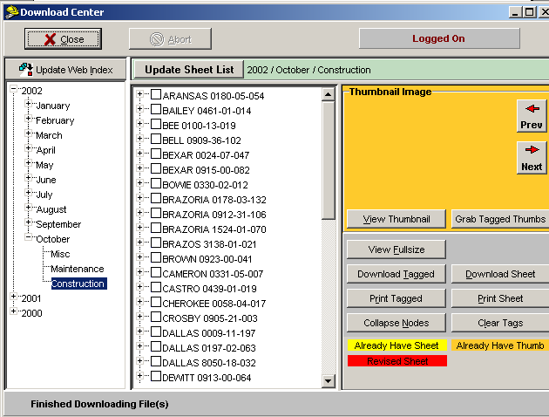

1

To download an Entire Job, click the box beside the county name and an “X” will appear in the box and the county will be highlighted (1). Then simply click Download Tagged (2). If you selected the wrong project, simply click in the box again and the “X” will disappear. If you have started downloading and realize it is the wrong job, click the Abort button (3).
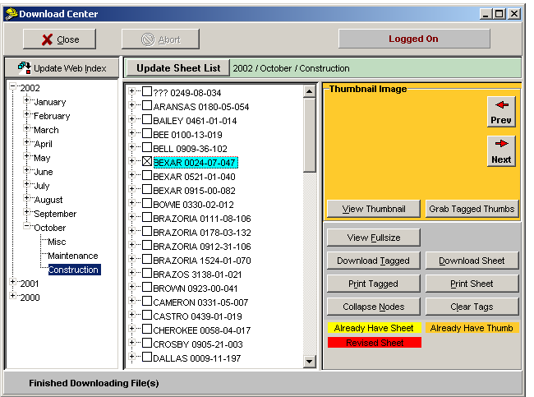
3

1

2

To download individual sheets, click the plus sign beside the county you need (1). Then browse through the sheets for the projects and put an “X” in the box next to the sheets you want to download (2). (The box beside the county name will be half marked. This shows that part of it has been selected.) Once you have all of the sheets marked, click the Download Tagged button (3). If you have started downloading and realize it is the wrong job, click the Abort button (4).
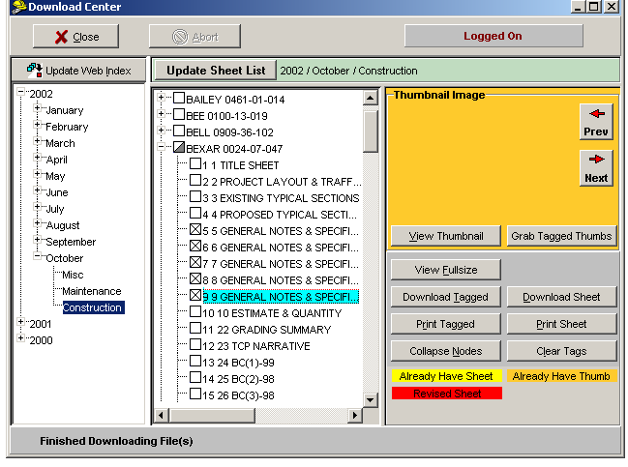
4

1

2

3

After the sheets have downloaded, they will be highlighted in yellow. You can also view a thumbnail image by selecting the box beside the image (1) and then clicking View Thumbnail (2). Those sheets will be highlighted in orange. The thumbnail views are located in the orange box in the right hand corner.

Revised sheets will be in red text. Once you download revised sheets, they will be highlighted in red.

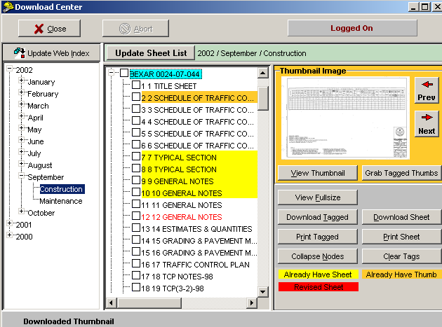

Image
1

2

To tag all revised sheets on one job or all revised sheets on all jobs for printing or downloading, right click on one of the counties. This will pull up a gray box with several options. You can use these options to do a multitude of things, including tagging the revised sheets.

Example: To tag all the revised sheets for the March 2003 letting, right click and select “Tag Revised and Addended Sheets – ALL Jobs” (1).
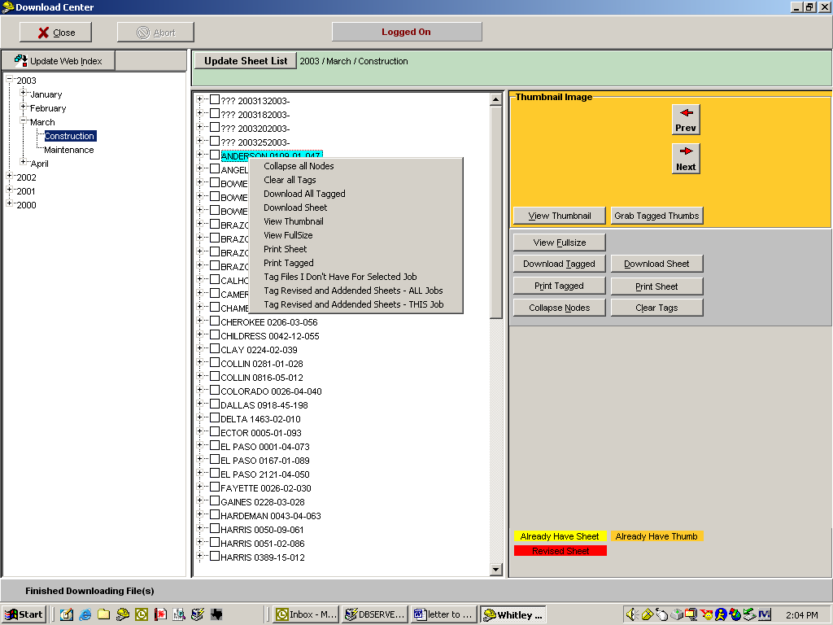
1

The program will mark all counties and sheets with revisions. (2) Then you can use them as you would any other sheets.
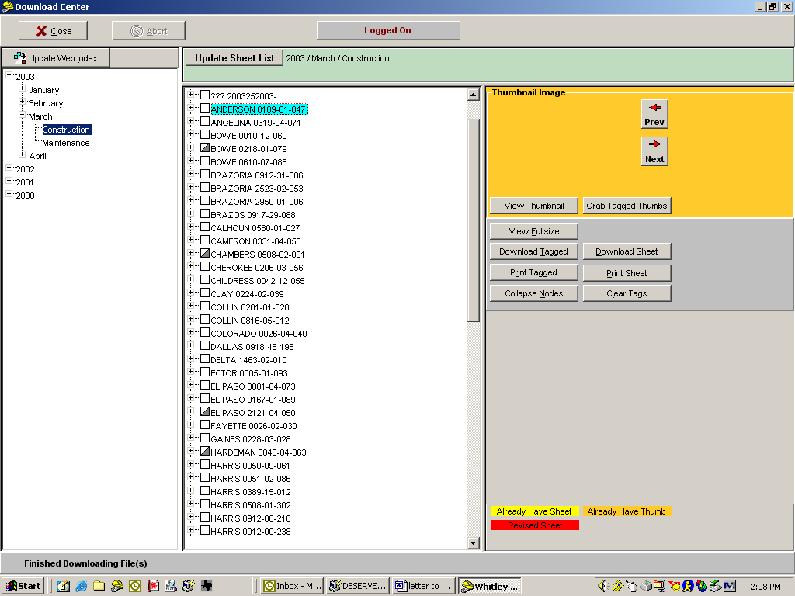
2

TO CORRECT 8.5X11” SHEETS:

Occasionally TxDOT will scan their plans in at the 8.5x11 size. To print the sheets in 11x17 format, find the sheets you would like to print and check their Tag box (1). An easy way to locate them is to use the Thumbnail at the top of the screen. (See page 2 on Thumbnail views)

Then check the Fix 8.5x11 box (2) at the bottom of the screen.
You can then choose to turn the sheet to the Right which is clockwise or to the Left which is counter-clockwise (3). When you click the Print Tagged Sheets button (4) and use your normal settings to print, the sheets will print out in 11x17 inch format.
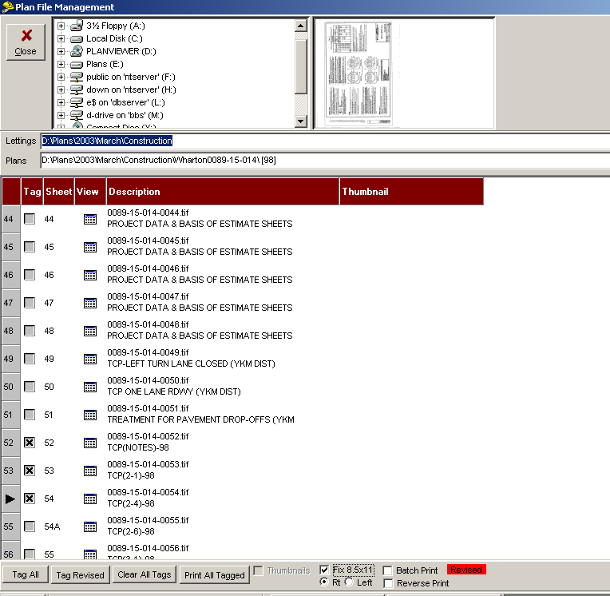

Thumbnail

1

4
2

3

FEATURE FOR INKJET PRINTER USERS:

If you have been resorting your pages because they stack in the opposite order (aka the last sheet is first and the first sheet is last), then this new feature will help you out! You can now print sheets in reverse order so that you do not have to resort them!

Once you have tagged all the sheets you wish to print, click the Reverse Print box (1) at the bottom of the screen. Then click Print All Tagged (2) and print your sheets like you normally would do. The printing will start at the last sheet so that it is on the bottom of the stack. The first sheet is on top of the stack when the printing is finished.

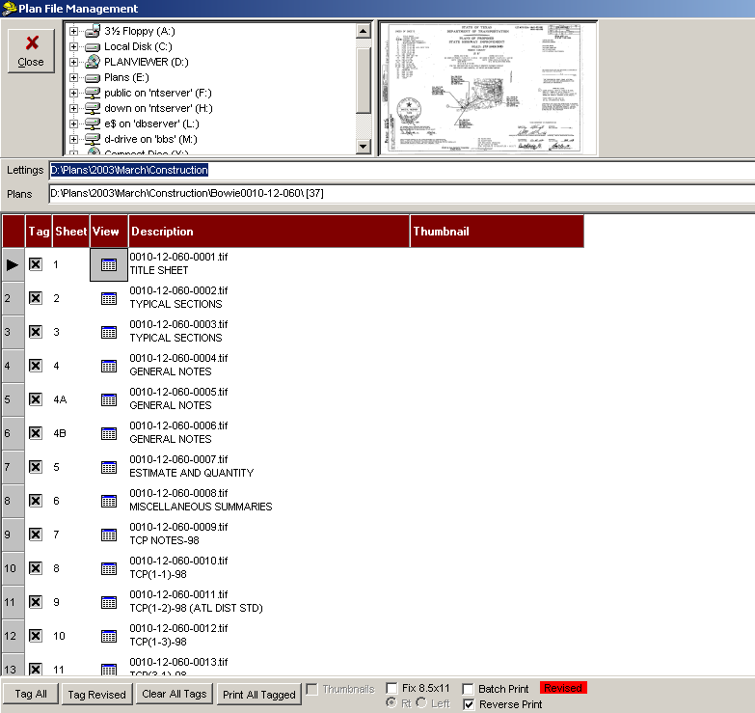

2

1

SEARCHING FOR SHEETS:

PlanViewer allows you to search for certain sheets in the project that you choose.

EXAMPLE: Say you are looking for sheets dealing with signs. Look up the project of your choice.

(1) Click on “Search”.
1
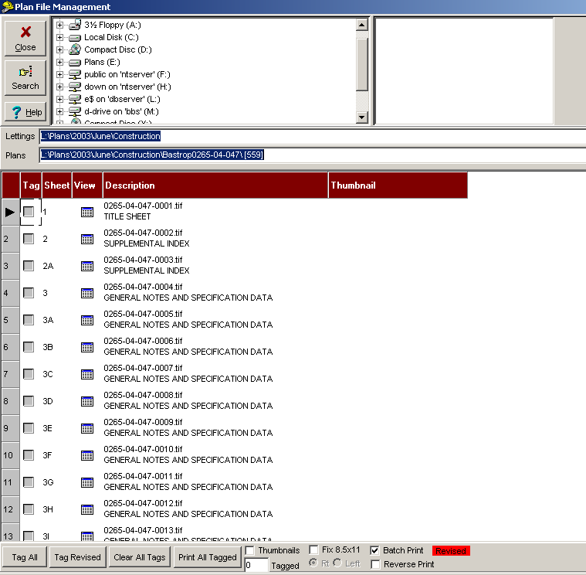

(2) Type in the sheets you are looking for in the white box. You can search for as many titles as you like. (i.e. General Notes and Index)
- Click on the “Tag” button.
- Lastly click on “Close”
2
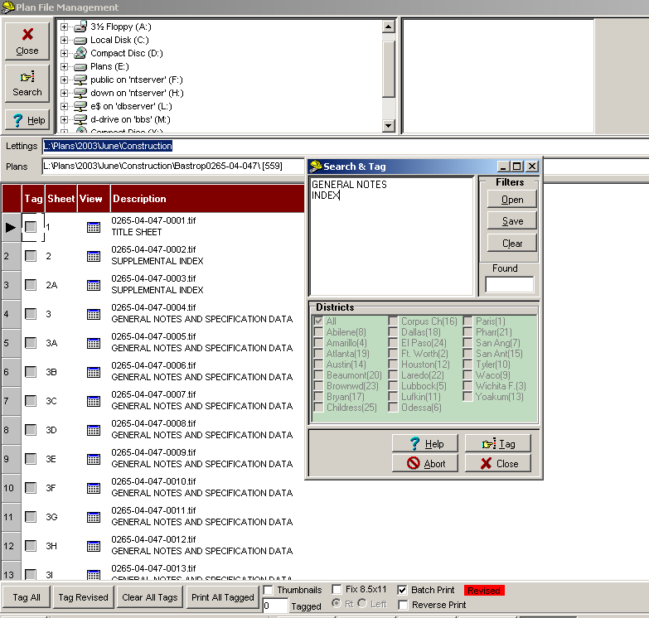
3
4
The search function will tag only sheets that have the word(s) you typed listed in the index. For instance, if you typed only SW3P, you might miss any sheets listed as TXDOT Storm Water Pollution Prevention. Therefore, it is better to search for both of them.

Once you have searched and tagged, you can also tag additional sheets by clicking on them or clear the tagged sheets just like you normally would. Printing is also the same.
There is a white box beside the “Print All Tagged” button that will give you the count of the sheets you tagged (5).
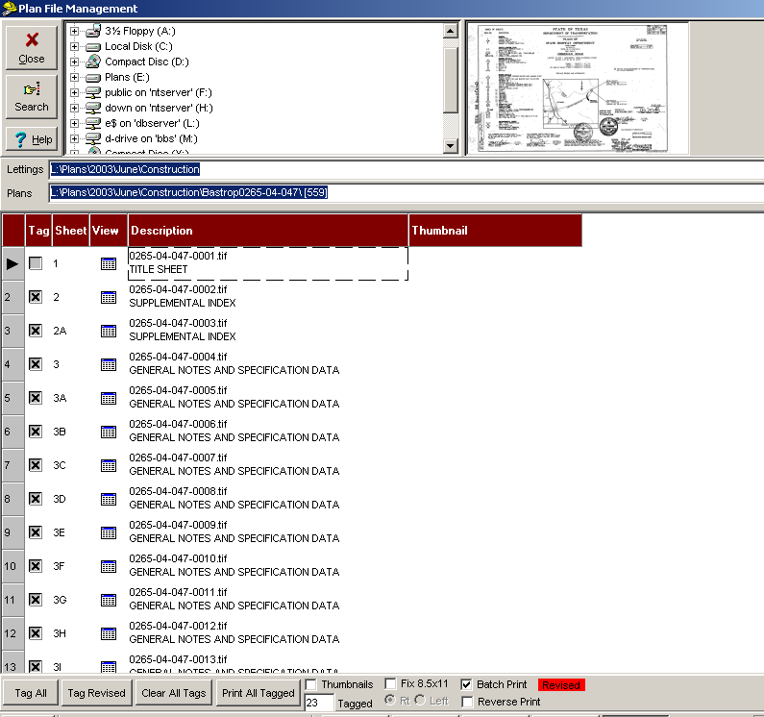
5

IF YOU HAVE ANY QUESTIONS ABOUT THE INSTRUCTIONS ON THESE PAGES, PLEASE FEEL FREE TO CALL JOE OR BRANDI @ 512-477-9491.

